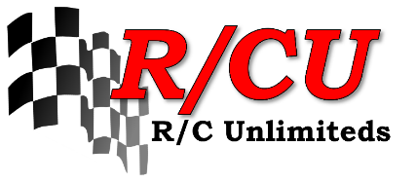
2023 Columbia Cup
Location: Kennewick, WA – Family Fishing Pond (Columbia Park Lagoon)

Schedule: Thursday, July 27 – Course setup, big boats arrive
Friday, July 28 – Testing: 10 AM to 5 PM
Saturday, July 29 – Testing: 7 AM to 9 AM
Driver’s Meeting: 9:05 AM, with racing to follow

Classes: 1/8th scale nitro, 1/8th scale fast electric, 1/10th scale electric, gas scale

Passes: Saturday only – $15 each, no pit entry
3-day pit pass – $30 each ($50 regular price); allows entry to Columbia Park Saturday and Sunday with restricted access* to unlimited hydro pits Friday-
Sunday
Vehicle Parking: FREE – required for all participants to park at the lagoon
Early Entrance: FREE – required for entrance to the park before 9 AM on Friday and Saturday
RV Passes (limited) – Contact Jason Walters, 509-222-0308
*No access is allowed behind the boats in the pits.

Ordering: Please order passes by filling out the form below and providing a check addressed to R/CU (or by paying online at https://www.rcunlimiteds.com/online-payment). Send the below form with a self-addressed stamped envelope (4-1/2 x 9-1/2) if you want tickets sent to your house, NO LATER than July 15th to:
Jason Walters
2913 S. Fruitland St.
Kennewick, WA 99337

2023 R/CU Columbia Cup Order Form

Name

Address

City, State, and ZIP

Date

Phone – Home or Cell, please circle

Email

Friday entry is FREE

Saturday-Only: $15.00 x _______________ = $________________________

3-Day Pit Passes: $30.00 x _______________ = $________________________

Vehicle Parking Passes x _________________ 1 per entry

Early Entrance Passes x ___________________ 1 per vehicle

